Note: Please refer to Unit test case plan for case description.

Unit Test case 1.1 Log-in Page:

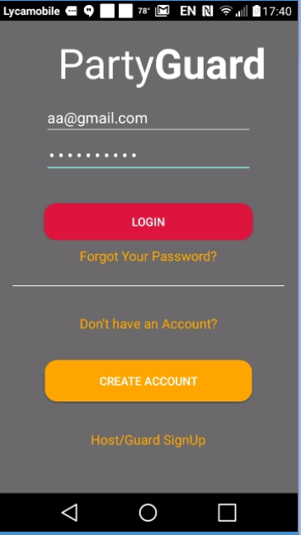

Unit Test case 1.2: User cant log-in if he does not enter password.

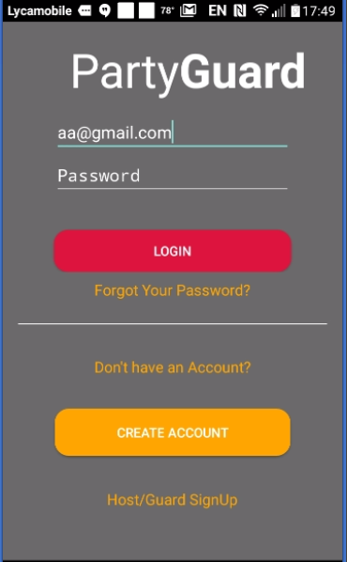

Unit test case 1.3 : Reset password

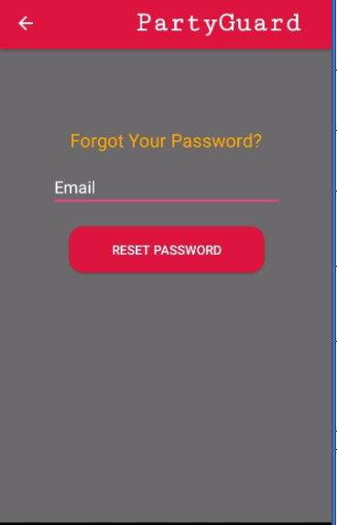

Unit test case 1.4 Create Account :

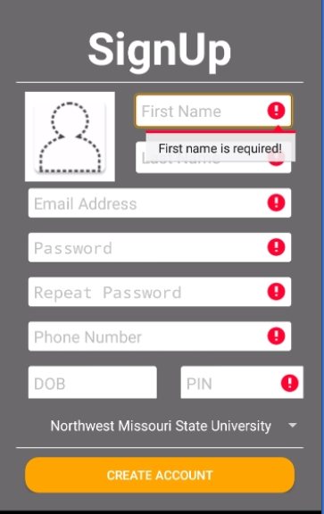

Unit test case 1.5: Host user log in

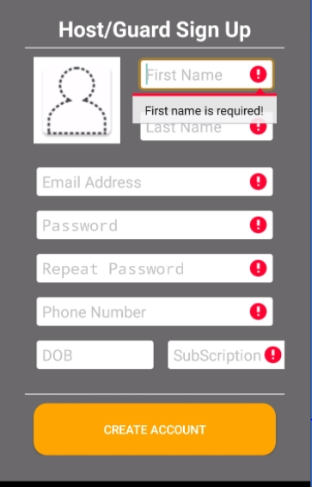

Unit test case1.6 : Photo selection from library

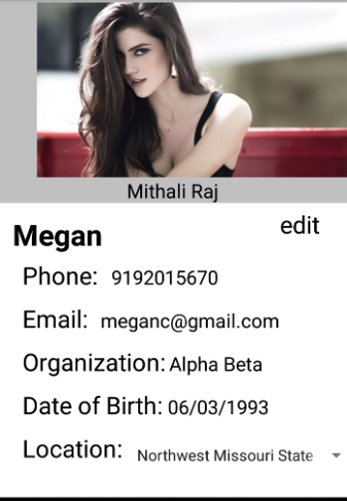

Unit test case 1.7: University selection

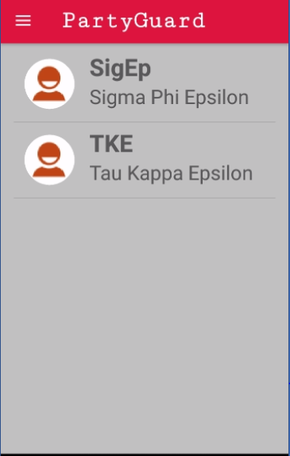

Unit test case 1.8: Fraternity is shown on top of the page along with issue types

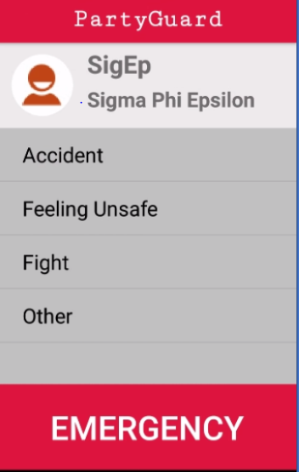

Unit test case1.9 : Fraternity locations populated .

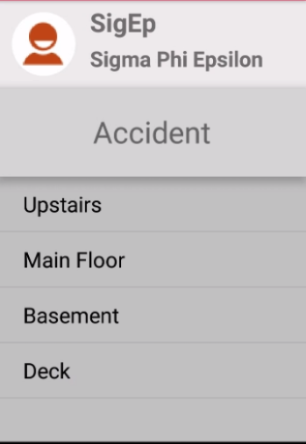

Unit test case 1.10 :Alert message

